Art and Model Guidelines

1. **Be cautious of flat Surfaces.**

There are no 100 % flat surfaces in nature. Play with the vertices, move them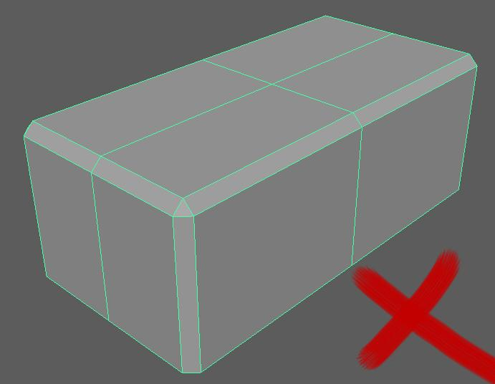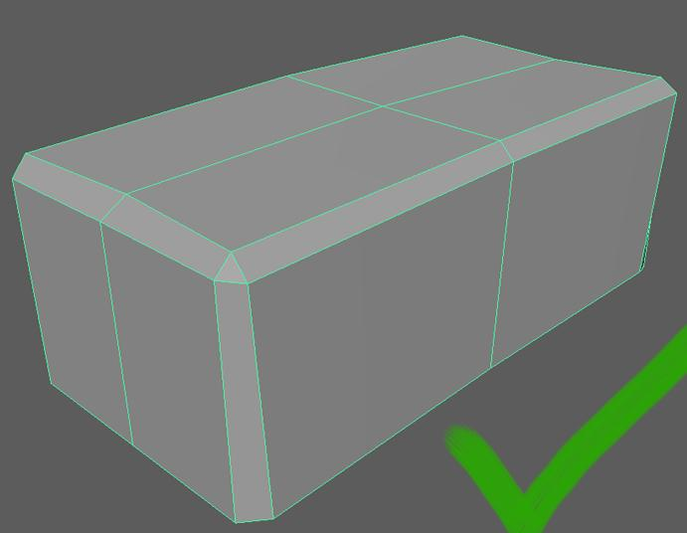

In math yes, but we’re simulating life. slightly. You can even use a randomize vertex

script to randomize the position of each vertex

by a small percent.

**2. Avoid single edge, 90 degree corners for objects larger than a cup.**

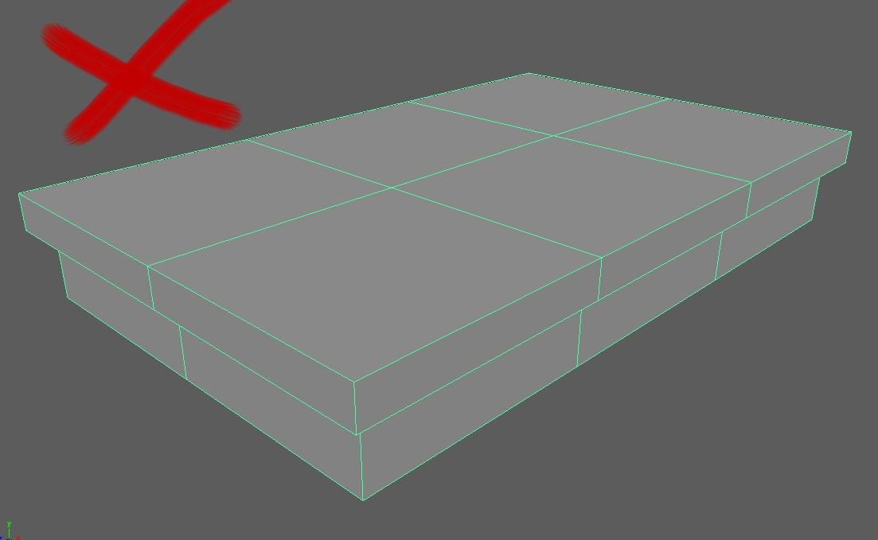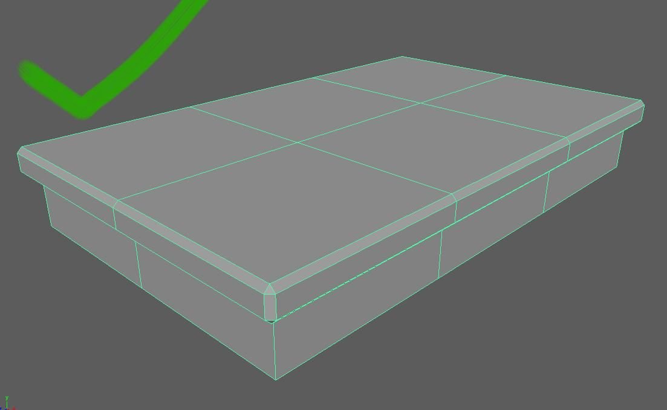

Once again, a perfect 90 degree edge does not exist. Apply a “bevel” to any “corner” edge for objects

Even if the edge seems extremely sharp, then it is only which are either; Taller, Wider or Deeper than

for extremely small objects that a single edge is used. a cup. Do make sure that sharp surfaces edges

never look too rounded or too sharp.

**3. Never use a single polygon / face for an entire surface area.**

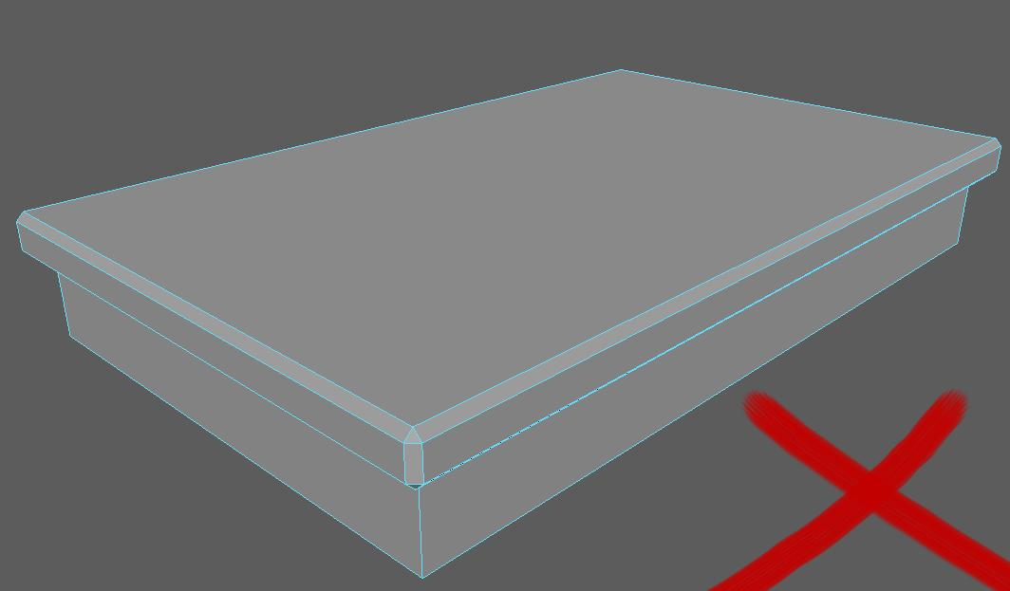

This is a part of the first point, be cautious of flat surfaces. A 100 % mathematically flat surface might sound compelling, but it kills art, quicky. Use the insert edge loop tool to create additional edges and move the vertices around to break up the uniform surface area. Use the edge distribution from point 2.

**4. Keep to a medium or “decent” polycount.**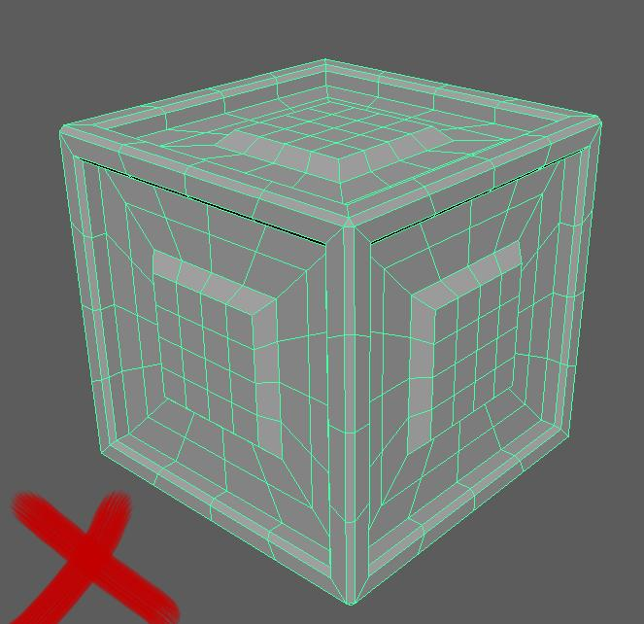

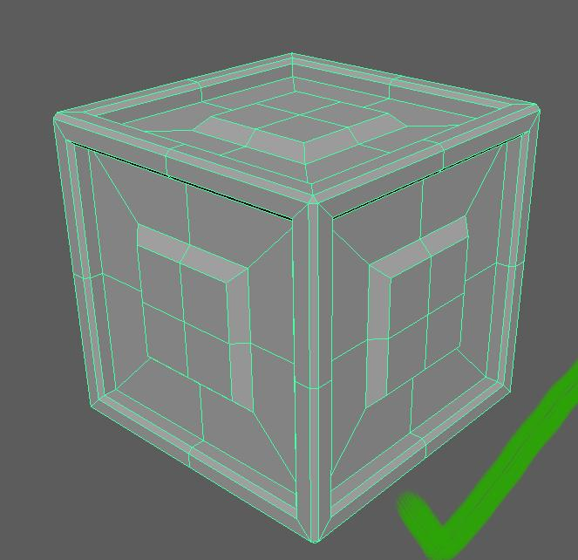

We’re neither high nor low poly, this can make it difficult In general, keep a max of 6000 polygons.

to distinguish how many polygons are appropriate. If you can remove an edge loop and it

does not break the silhouette of the object, then

keep it removed.

**5. Keep textures and normal maps free of details. (Except for engravings and ornamentation)**

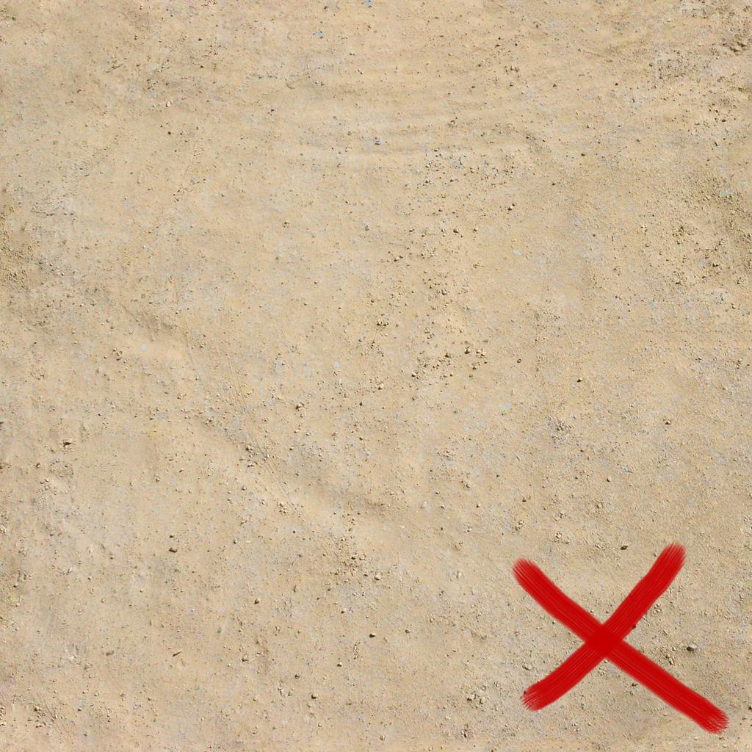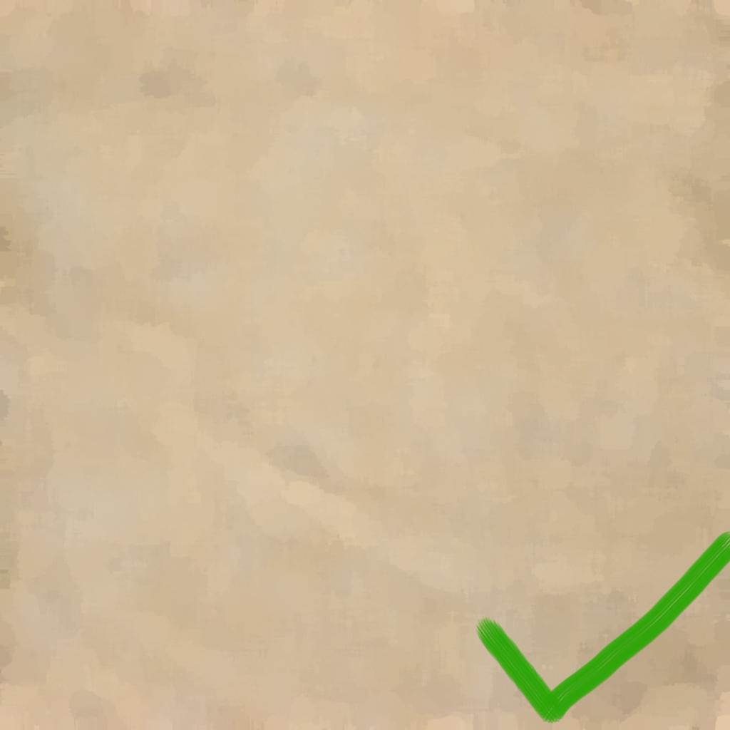

We’re trying to go for a minimalistic approach without Either use hand painting or try to downscale

going into low poly territory. This means that most Textures and pictures if used. Photoshop

textures should approach the “flat color” color spectrum. has an artistic filter called “paint daubs” which

is a great way of removing details from a texture.

File Conventions.

* Export as FBX with

Geometry:

Smoothing Groups: Enabled

Everything Else: Disabled

DON’T EXPORT ANIMATIONS, TEXTURES, MATERIALS INTO THE

MODEL FBX.

* Name the models with the prefix of the level and then the name from the scrum list.

Example:

Level 1. Egyptian Chest, Wooden.

lv1_Egyptian_Chest_Wooden.fbx

Don’t include: , . “ / ( ) : ; = ? + in filenames. Only underscores

* Export Textures as TGA. (Yes it is annoying, but it is the only format in unity which support specular, gloss, roughness and alpha maps)